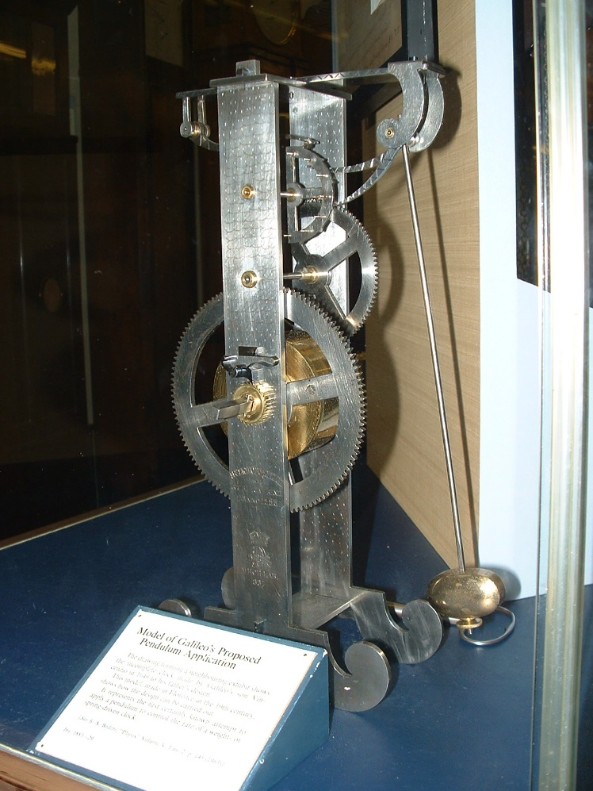Galileos clock which works on principle of pendulum .

The formula for the period T of a pendulum is **T = 2π Square root of√L/g**, where L is the length of the pendulum and g is the acceleration due to gravity.

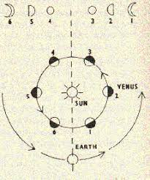

galileo mapping of venus phases

Galileo Galilei's observations that Venus appeared in phases -- similar to those of Earth's Moon -- in our sky was **evidence that Venus orbited the sun and contributed to the downfall** of the centuries-old belief that the sun and planets revolved around Earth.

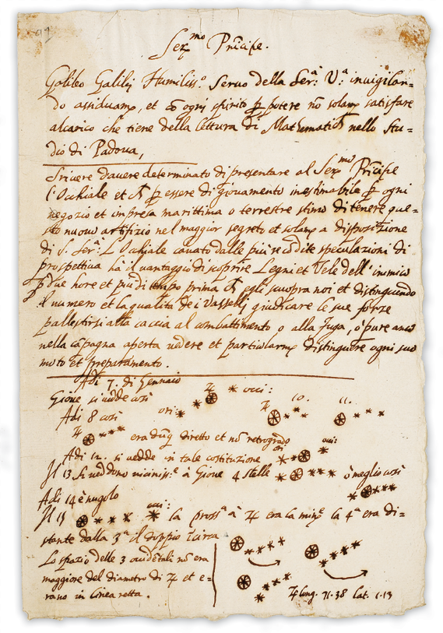 Galileo's principle of relativity states "**It is impossible by mechanical means to say whether we are moving or staying at rest**". If two trains are moving at the same speed in the same direction, then a passenger in either train will not be able to notice that either train is moving

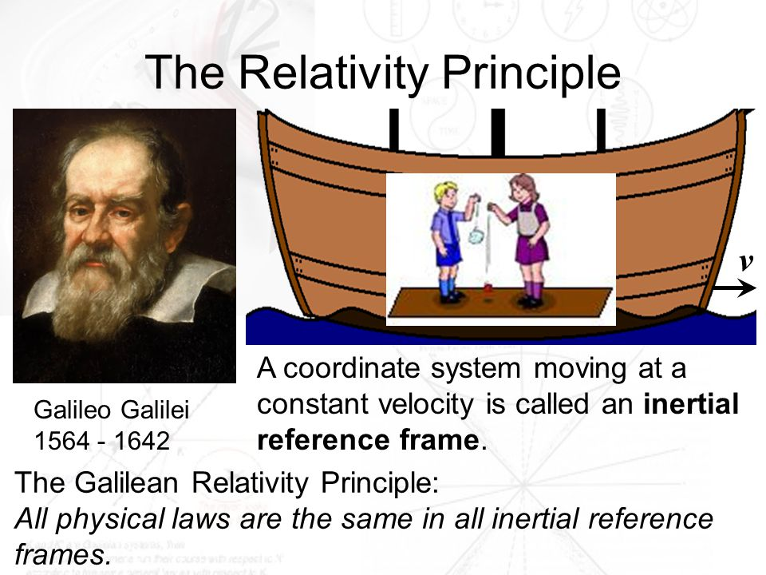

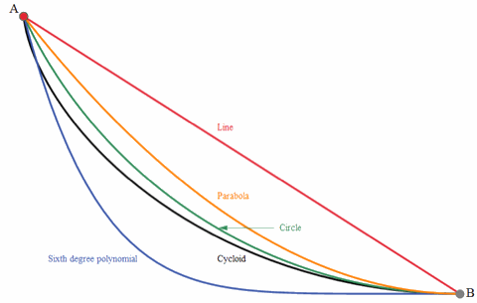

Brachistochrone Problem: Which path from A to B is traversed in the shortest time? (Click image to animate.) This is the Brachistochrone (“Shortest Time”) Problem. ... Galileo studied motion under gravity, showing that **a body falling in space traverses a distance proportional to the square of the time of descent**.

**Galileo's paradox** is a demonstration of one of the surprising properties of [infinite sets](https://en.wikipedia.org/wiki/Infinite_set). In his final scientific work, [*Two New Sciences*](https://en.wikipedia.org/wiki/Two_New_Sciences), [Galileo Galilei](https://en.wikipedia.org/wiki/Galileo_Galilei) made apparently contradictory statements about the [positive integers](https://en.wikipedia.org/wiki/Positive_integers). First, some numbers are [squares](https://en.wikipedia.org/wiki/Square_number), while others are not; therefore, all the numbers, including both squares and non-squares, must be more numerous than just the squares. And yet, for every number there is exactly one square; hence, there cannot be more of one than of the other. This is an early use, though not the first, of the idea of [one-to-one correspondence](https://en.wikipedia.org/wiki/Bijective_function) in the context of infinite sets.

Galileo concluded that the ideas of *less*, *equal*, and *greater* apply to (what we would now call) [finite sets](https://en.wikipedia.org/wiki/Finite_set), but not to infinite sets. In the nineteenth century [Cantor](https://en.wikipedia.org/wiki/Georg_Cantor) found a framework in which this restriction is not necessary; it is possible to define [comparisons amongst infinite sets](https://en.wikipedia.org/wiki/Cardinality#Comparing_sets) in a meaningful way (by which definition the two sets, integers and squares, have "the same size"), and that by this definition [some infinite sets are strictly larger than others](https://en.wikipedia.org/wiki/Cantor%27s_theorem).

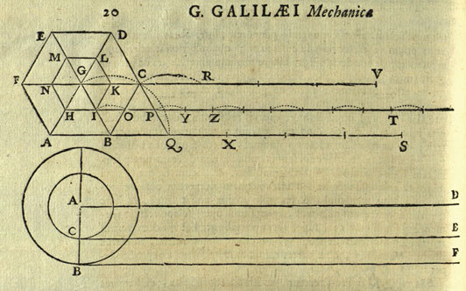

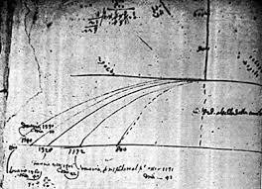

Using an inclined plane, Galileo had performed experiments on uniformly accelerated motion, and he now used the same apparatus to study projectile motion. He placed an inclined plane on a table and provided it with a curved piece at the bottom which deflected an inked bronze ball into a horizontal direction. The ball thus accelerated rolled over the table-top with uniform motion and then fell off the edge of the table Where it hit the floor, it left a small mark. The mark allowed the horizontal and vertical distances traveled by the ball to be measured.

